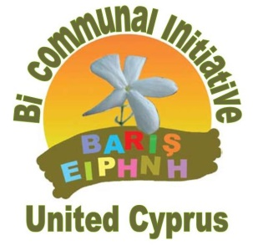
Bi-communal Peace Initiative – United Cyprus

Meeting at UNFICYP

Press Release

A broad delegation of the Bi-communal Peace Initiative – United Cyprus met yesterday with senior officials from the United Nations Peacekeeping Force in Cyprus (UNFICYP). The delegation had an extensive exchange of views and ideas with the UNFCYP officials on ways to continue to build a culture of peace and trust in Cyprus as part of efforts to reach a solution.
The delegation of the Bi-communal Initiative reiterated its appreciation of the pivotal role played by UN Secretary-General António Guterres at the conference on Cyprus in Crans Montana, and also through his proposals on the issue. The delegation further expressed its appreciation of the work of the Special Representative of the Secretary-General in Cyprus, Ms. Elizabeth Spehar, and the positive role that the Initiative hopes her Office can play in efforts to create conditions conducive to a solution.
The delegation underlined its position that the key issues that led to a deadlock in Crans Montana are considered by ordinary Cypriots as bridgeable, and that the broader masses of Turkish Cypriots and Greek Cypriots are ready to accept the compromises required for a successful conclusion of the negotiations. The Bi-communal Initiative urges the Leaders of the two Communities to respond positively to the key issues put on the table by the UN Secretary-General, thereby clearing the path for the reconvening of the negotiation process and, ultimately, for a successful conclusion of the process
The Bi-communal Initiative outlined its plans to engage Civil Society more actively in pushing for these developments, and continues to seek ways in which Civil Society can become an active stake holder in the negotiation process. Whilst the Initiative will seek the involvement of the Leaders of the two communities, it also encourages the UN to look into ways of boosting its engagement with Civil Society as a legitimate stake holder in this process.
Concluding the meeting, it was agreed that the consultation process should be continued, with the expectation that it will contribute to efforts to achieve a united, federal Cyprus.
Bi-communal Peace Initiative – United Cyprus
30th November, 2017

