APPLICATION FORM FOR SUMMER 2015

Name and Surname:  School: Date of birth:  Town or village: | Please add your photo here

I am applying for:  (tick one box) | CFP in US |  | CFP Camp in Cyprus |  | Both

THIS FORM TO BE COMPLETED BY THE TEENAGER AND HIS/HER PARENTS/GUARDIANS

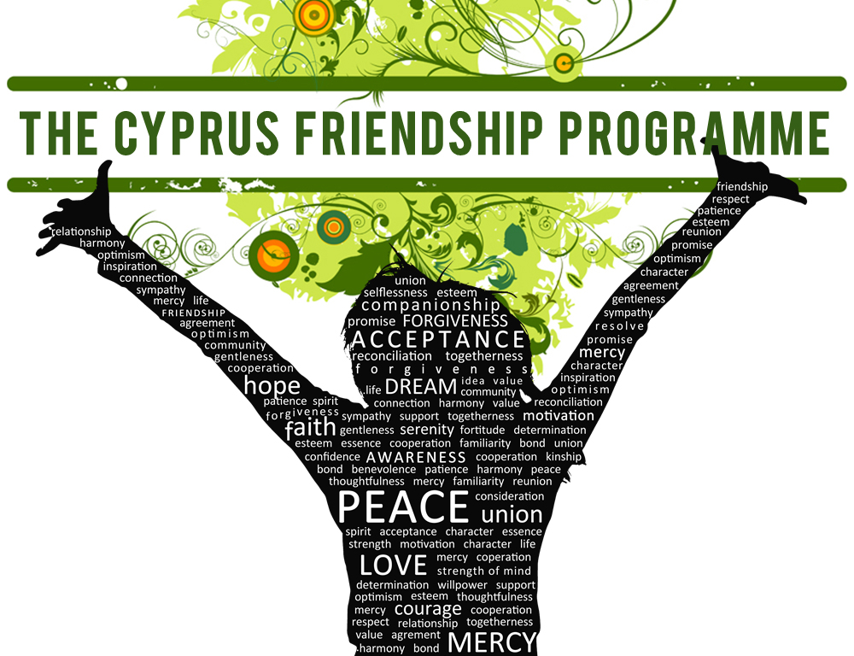

IN A COUNTRY DIVIDED…PEOPLE UNITED
Before completing this form please print and read the accompanying document "Information for parents and teens applying for the summer 2015 group"

Once completed the application form and the sealed envelope with the recommendation letter (see pages 13-14) must be given or mailed to any of the following Cypriot coordinators no later than the 23rd of February, 2015. Early submissions will be greatly appreciated!

 | Phone No. | E-mail | Address
Simge  Kahvecioglu | 05428564828  2270525 | simgekahvecioglu@hotmail.com | 6 Aksekiz Apt, D2, Sht Murat İlhan Str, Kumsal, Nicosia
Nicos  Anastasiou | 99498531  24530203 | nicosiew@spidernet.com.cy | 119 Makarios Av. Aradippou, Larnaca, 7120
Sarper Ince | 05338409792  2278316 | sarper_ince@hotmail.com | Okay 16 Apt. No.3, Mehmet R. Huseyin Str, Yenisehir, Nicosia
Sotia  Adamidou | 99327178  22352361 | sotia_adamidou@outlook.com | 13 Kronou Makedonitissa, Nicosia, 2400
Cise  Sakalli | 05338635183  2275077 | cisesakalli@gmail.com | 61 İzem Apt.2, D1, Sht Mehmet Kemal Str, K.Kaymakli, Nicosia
Nicolina Karaolia | 99552664 | nicolinak@gmail.com | Epidavrou 12, Aglantzia 2114, Nicosia
Vladimiros Taliadoros | 99438749  22324369 | vladimta@cytanet.com.cy | 2 Narkissou, Strovolos, 2045 Nicosia

CHECKLIST
After completing the form please check and tick in the boxes below:
 | YES | NO
Your photo placed on page 1.
On page 1 tick one box clarify if you are applying for the US part of CFP, the summer camp in Cyprus or both. (‘Both’ means that if you are not selected for the US part, you may be selected for the summer camp in Cyprus).
The whole of the original and two photocopies of pages 1-8 of this form.
Note: If applying for camp only, the whole of the original and only one photocopy of pages 1-8 is needed.
Original signatures of teenager and/or parent/guardian and dates put on pages 6 and 9-12 of this application form. For camp only, sign on pages 6 and 12.
Two copies of your most recent grade report from school.
Two copies of a valid passport that can be used to fly from Larnaca. (Only if you are applying for CFP in the US). If you do not have a valid passport, notify with evidence that you have started the process of applying for one.

15 euros application fee (put in a small envelope).
One letter of recommendation in a sealed envelope to be written by a teacher from your school (see pages 13-14 for instructions).

Depending if you are applying for the US, the Cyprus camp or both the table below is a guide of which parts of the application form to complete:

PARTS OF THE APPLICATION FORM | IF APPLYING FOR CFP IN US ONLY | IF APPLYING FOR CFP CAMP IN CYPRUS ONLY | IF APPLYING FOR BOTH
A | √ | √ | √
B | √ | √ | √
C | √ | √ | √
D | √ |  | √
E | √ |  | √
F | √ |  | √
G |  | √ | √
H | √ | √ | √
I | √ | √ | √
PART A: TEEN AND PARENTS/GUARDIANS INFORMATION
Teenager’s Full Name
Country of Birth |  |  |  |  | Gender
Home address
Home telephone |  |  | Mobile phone no.
Teenager’s email | (write very clearly)
Current school |  |  |  | School phone no.
How many more years in school will you have after the summer of 2015?
Country of citizenship
Passport number and expiry date |  |  | Country of issuance
Mother’s name |  |  | Father’s Name
Mother’s occupation |  |  | Father’s occupation
Mother’s nationality |  |  | Father’s nationality
Mother’s mobile no. |  |  | Father’s mobile No.
Mother’s work no. |  |  | Father’s work No.
Mother’s email address | (write very clearly)
Father’s email address | (write very clearly)
Parent’s marital status (e.g. married, divorced, widowed)
Names and ages of any brothers and sisters
Names of family members and year previously involved with the CFP, or other peace programmes (if any)
Applied to CFP US or CFP Camp before? If so, which year?
Name and phone (optional) of teacher writing recommendation (see pages 13-14)
How did you hear about the programme?
PART B: ESSAY QUESTIONS
(To be completed by hand by the teenager)
- What is the greatest challenge you have faced in your life? How did you manage this challenge?
…………………………………………………………………………………………………..
…………………………………………………………………………………………………..
…………………………………………………………………………………………………..
…………………………………………………………………………………………………..
…………………………………………………………………………………………………..
…………………………………………………………………………………………………..
…………………………………………………………………………………………………..
…………………………………………………………………………………………………..
…………………………………………………………………………………………………..
- List any clubs or activities you have been involved in, awards or prizes you may have earned. Use additional paper if needed.

Activities, clubs | Year(s)

Awards, prizes | Awarding body | Year
- Describe the main activities, and the clubs mentioned in question (2).
…………………………………………………………………………………………………..
…………………………………………………………………………………………………..
…………………………………………………………………………………………………..
…………………………………………………………………………………………………..
…………………………………………………………………………………………………..
…………………………………………………………………………………………………..
…………………………………………………………………………………………………..…………………………………………………………………………………………………..…………………………………………………………………………………………………..…………………………………………………………………………………………………..
- CFP is expecting a contribution from you in the following year. How do you plan to combine your academic work with CFP peace building work in the following year.
…………………………………………………………………………………………………..
…………………………………………………………………………………………………..
…………………………………………………………………………………………………..
…………………………………………………………………………………………………..
…………………………………………………………………………………………………..
…………………………………………………………………………………………………..
Full name of teenager applying:
Signature: Date:

By signing this application, you confirm that the information is correct, to the best of your knowledge, and that you have completed the essay questions yourself without assistance.

PART C: FOR THOSE APPLYING FOR THE US PROGRAMME AND/OR THE SUMMER CAMP IN CYPRUS

(To be completed by parents/guardians)

Does the teenager have any medical (mental and/or physical) or dental conditions? |  |  |  | Yes No
If yes, please describe:
List any medications the teenager is currently taking:
Describe any allergies to food, medication, pets, or other substances:
Food preferences e.g. vegetarian, what the teen likes, dislikes etc.
Has the teenager ever been arrested? | Yes No |  | If so, provide details:
Can the teenager swim? | Yes No |  | How well?
Can the teenager take care of himself/herself in the sea or swimming pool? |  |  |  | Yes No
Do parents/guardians consent to the teenager being interviewed by the press or other media or being on television while in Cyprus or the US? |  |  |  | Yes No
Parents/guardians, please describe your family (in English, Turkish or Greek):

PART D: FOR THOSE APPLYING FOR THE US PROGRAMME

(To be completed by parents/guardians)

Has the teenager ever been to the United States? | Yes No | If so when, where, why and for how long?
Has the teenager ever spent any length of time away from home? | Yes No | How long?
Name and address of any relatives living in United States (if any):
The CFP includes an intensive four-week project in the U.S. that may be both physically and emotionally challenging. Will the teenager need any special accommodations for medical conditions, health issues, special needs, etc., while they are participating in the programme?

Does the teenager have any eating preferences or dislikes that will be useful for the US host family to know? For example is he/she a vegetarian?

Many American families have pets living in the same home with them. Does the teenager have any problems with any kind of animals and if so which ones? We will try but we cannot guarantee that the teenager will not be placed in a home without pets.

Would you object to the teenager attending a service associated with other religions? |  |  | Yes No

- Any other information that you feel is relevant but is confidential in nature should be included on a separate sheet of paper.
PART E: FOR THOSE APPLYING FOR THE US PROGRAMME
(To be signed by the teen and one parent/guardian)
Not: 9’den 11’a kadar olan sayfaların bir adet Türkçe ve Rumca çevirileri ekte verilen ‘‘Yaz 2015 grubu için başvuran ebeveyn ve gençler için bilgi“ adlı dokümanda bulunabilir.

Σημείωση για τους γονείς: Οι σελίδες 9-11 στις οποίες υπογράφετε ότι συμφωνείτε με τους κανονισμούς του προγράμματος είναι μεταφρασμένοι στα Ελληνικά στο τέλος του συνοδευτικού κειμένου με τίτλο “Information to parents and teens applying for the summer 2015 group”.
Please INITIAL (the first letters of your first and last names) all of the following:
 | Parent/  Guardian  initials | Teenager  Initials
We understand that “No Smoking” laws are strictly enforced in the United States. Smoking is not permitted at CFP events in Cyprus or while the teenagers are in the United States.
My teen and I understand that while in the United States he/she agrees to:
- Observe Programme rules;
- Observe all United States laws, including those related to the drinking and smoking age;
- Engage in no behavior that would bring the Programme into disrepute; and
- Treat the Programme and associated people with respect.
Failure to comply with any of these may result in the participant being immediately sent home at their family’s expense.
Other consequences, depending on the severity of misbehavior may follow, including not awarding the CFP graduation certificate.
The teenager will be matched with another young person of the same gender, but of a different community. The purpose of this Programme is for them to get to know and understand each other within a neutral environment. They will share a bedroom while in the host family home and will hopefully build a lasting friendship. Parents/guardians should encourage the two young people who have been matched to have as much contact as possible (including a visit to each others home, if possible) before their departure date.
Early and ongoing contact between families of the paired participants is important for the Programme’s success. Parents/guardians as well as participants must be willing to become friends with their CFP partner and the partner’s family.
All participants must attend follow-up activities, including active participation in an alumni program after they return home. The Cypriot Coordinators will provide information on this at a later time.
The teenager must be mentally and physically capable of handling a four-week absence from home.
We understand that the teenagers are not permitted to possess more than $500 in cash and that they are not allowed to bring any credit cards with them to the United States.
It is required that the parents/guardians and the teenager attend the Graduation Ceremony in Cyprus in October (exact date and location to be provided at a later time).
Teenagers and parents/guardians are required to read the CFP document “Information to parents and teens applying for the 2015 CFP group” and agree to abide with all project rules contained therein.
We understand that the teenager is not permitted to bring or use mobile phones and any other electronic devices whether it can be connected to the internet or not (i-pods, tablets, android devices, mp-players and so on) during their length of stay in the United States. If any such devices are found, they will be confiscated. Other consequences, depending on the severity of misbehavior may follow, including not awarding the CFP graduation certificate.
We understand that the teenager is not permitted to use the internet in general and particularly Facebook, other social media and e-mails during her/his stay in the US.

Note: Some exceptions to the rules concerning the use of the internet can be found in the document "Information for parents and teens applying for the summer 2015 group."

PART F: FOR THOSE APPLYING FOR THE US PROGRAMME

(To be signed by one parent/guardian only)

Initial
We understand that the contribution to the programme is between $700 and $800. Families who are willing to contribute an additional amount will help the programme in covering its considerable expenses.
We give CFP permission to contact schools and/or others for references on the teenager.
We agree to pay for all expenses associated with the return of my teenager if he or she is sent home by the CFP Executive Director for any reason, other than a health emergency.
If parents/guardians or teenager insist on being returned home due to medical conditions that may arise, other than a medical emergency, such travel will be at the parents’/guardians’ expense.
The Programme insures the teenager for medical and dental coverage. However, the insurance does not cover any preexisting medical/dental problem or injuries received while participating in hazardous sports listed by our insurance carrier. THESE EXCLUSIONS APPLY IN ALL CASES.
I/We the Parents/Guardians and the teenager understand the purpose of the Programme, and we agree to the teenager’s spending four weeks in the United States with a partner of a different community.

PART G: FOR THOSE APPLYING FOR THE CAMP IN CYPRUS

Parent/Guardian initials | Teenager Initials
 |  | We understand that smoking and drinking are not permitted at the CFP camp in Cyprus.

Parent/Guardian initials
I/We the Parents/Guardians agree to the teenager’s participation in the Cyprus Friendship Programme camp and in the activities during and after the camp in Cyprus.

PART H: FOR THOSE APPLYING FOR THE US PROGRAMME AND THE CAMP IN CYPRUS

Full name of mother/guardian:
Signature: Date:

Full name of father/guardian:
Signature: Date:

Full name of teenager applying:
Signature: Date:

By signing this application, we confirm and agree to the following:

- All information above is correct, to the best of our knowledge;
- We have read, understand, and agree to all the foregoing information; and
- We absolve CFP Inc., CFP in Cyprus, its volunteers, officers, directors, host families, and any support families of any liability associated with the participation of our child in the Programme.
- Once completed, this form may be shared with others in the programme.
PART I: LETTER OF RECOMMENDATION

Instructions to parents and the teacher making the recommendation:

- Pages 13 and 14 should be detached and given to be completed in English by a teacher from the school of the teenager.
- The teacher will then put the letter in an envelope and seal it with his/her signature crossing the sealed part. The name of the teenager should be written on the front of the envelope followed by the words “Application for the 2015 Cyprus Friendship Programme”.
- The signed and sealed envelope to be given to the teenager’s parents for submission to the Cypriot coordinators together with the application form.
……………………………………………………………………………………………………………

Name and position of teacher: _______________________________________________

Telephone (optional): ________________ Student’s name: _______________________

School: ________________________________

Compared with other students you have taught how do you rate this student? Please tick:
 | 1. Below  Average | 2. Average | 3. Good | 4. Very good | 5. Excellent
Academic achievement
Maturity

Leadership
Abilities
Level of English

Creative, original thought
Conduct
(behaviour)
Briefly describe why this teenager is mature and responsible enough to:
(a) spend one month with a teen from the other community with a host family in the U.S. and/or
(b) spend one week in a bi-communal camp in Cyprus.
Note for teacher: If the teen is applying for US only, then answer part (a) only. If applying for camp only answer (b) only. If applying for both the US and the camp answer both (a) and (b).
…………………………………………………………………………………………………..
…………………………………………………………………………………………………..
…………………………………………………………………………………………………..
…………………………………………………………………………………………………..
…………………………………………………………………………………………………..
…………………………………………………………………………………………………..
…………………………………………………………………………………………………..
…………………………………………………………………………………………………..
…………………………………………………………………………………………………..
…………………………………………………………………………………………………..
……………………………………………………………………………………………………………………………………………………………………………………………………………………………………………………………………………………………………………………………………………………………………………………………………………………………………………………………………………………………………………..
Name of teacher:

Signature: Date:

